Experiment No – 1
Title / Aim :- Demonstrate inline, internal, and external JavaScript; use console methods; create a webpage showing user info and a welcome message.

Software/Tools Required :-
- Visual Studio Code (VS Code)
- Google Chrome / Any Web Browser
- HTML
- JavaScript

Code:-
Index.html
<!DOCTYPE html>
<html lang="en">

<head>
<meta charset="UTF-8">
<meta name="viewport" content="width=device-width, initial-scale=1.0">
<title>JavaScript Experiment 1</title>

<style>
body {
margin: 0;
font-family: Arial, sans-serif;
background-color: #eef5ff;
}

.header {
background-color: #4CAF50;
color: white;
padding: 18px;
text-align: center;
}

.container {
width: 60%;
margin: 30px auto;
background: white;
padding: 20px;
border-radius: 8px;
border: 2px solid #4CAF50;
}

table {
width: 100%;
border-collapse: collapse;
margin-top: 15px;
}

table, th, td {
border: 1px solid gray;
}

th {
background-color: #4CAF50;
color: white;
padding: 10px;
}

td {
padding: 10px;
}

.buttons {
text-align: center;
margin-top: 25px;
}

button {
background-color: #4CAF50;
color: white;
border: none;
padding: 10px 18px;
margin: 8px;
border-radius: 5px;
cursor: pointer;
}

button:hover {
background-color: #388E3C;
}

#message {
text-align: center;
color: darkblue;
font-weight: bold;
margin-top: 15px;
}
</style>

<script>
function showProfile() {

document.getElementById("message").innerHTML =
"Welcome to JavaScript Lab!";

document.getElementById("name").innerHTML =
"Shivangi Kushwaha";

document.getElementById("roll").innerHTML =
"24070521164";

document.getElementById("branch").innerHTML =
"Computer Science and Engineering with AIML Specialization";

document.getElementById("semester").innerHTML =
"5th Semester";

console.log("Profile Displayed");
console.info("Internal JavaScript Executed");

}
</script>

</head>

<body>

<div class="header">
<h1>Student Information Dashboard</h1>
</div>

<div class="container">

<table>

<tr>
<th>Field</th>
<th>Information</th>
</tr>

<tr>
<td>Name</td>
<td id="name">---</td>
</tr>

<tr>
<td>Roll Number</td>
<td id="roll">---</td>
</tr>

<tr>
<td>Branch</td>
<td id="branch">---</td>
</tr>

<tr>
<td>Semester</td>
<td id="semester">---</td>
</tr>

</table>

<p id="message">Click any button below.</p>

<div class="buttons">

<button onclick="alert('Welcome to JavaScript! Shivangi...');">
Inline JS
</button>

<button onclick="showProfile()">
Internal JS
</button>

<button onclick="showConsole()">
External JS
</button>

</div>

</div>

<script src="script.js"></script>

</body>

</html>

Script.js
function showConsole() {

alert("External JavaScript File Executed");

console.log("Console Log");
console.warn("Console Warning");
console.error("Console Error");
console.info("Console Information");

let student = [
{
Name: "Shivangi",
Branch: "AIML",
Semester: "3rd"
}
];

console.table(student);

}

Output

Inline JS

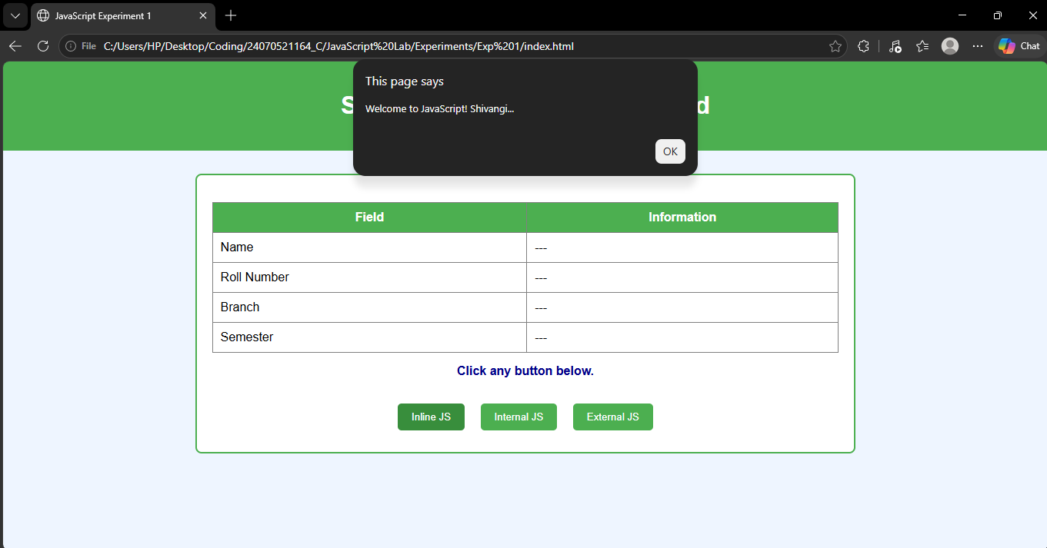

Internal JS
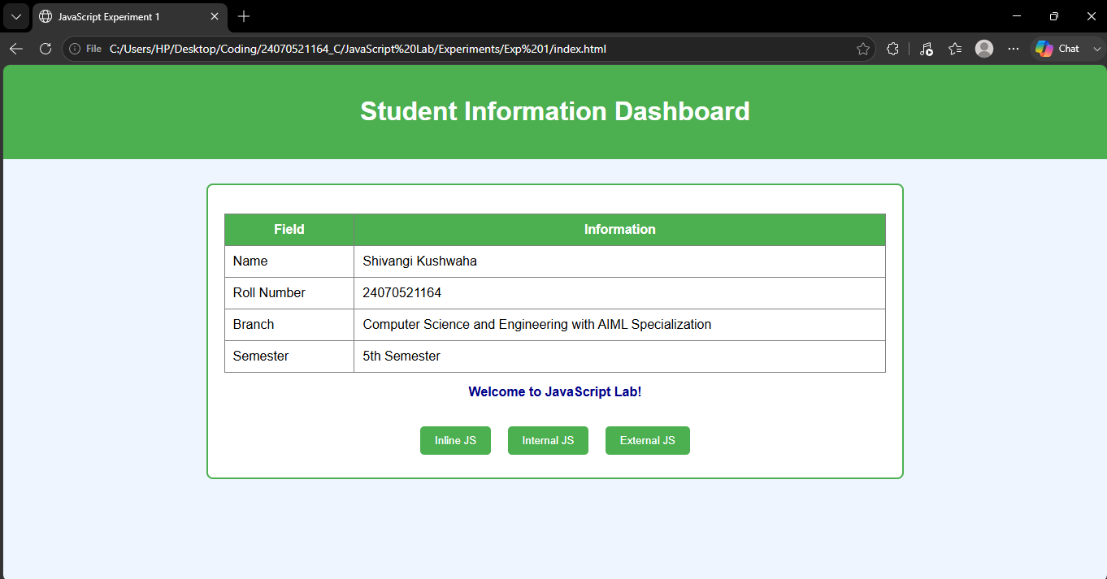

External JS

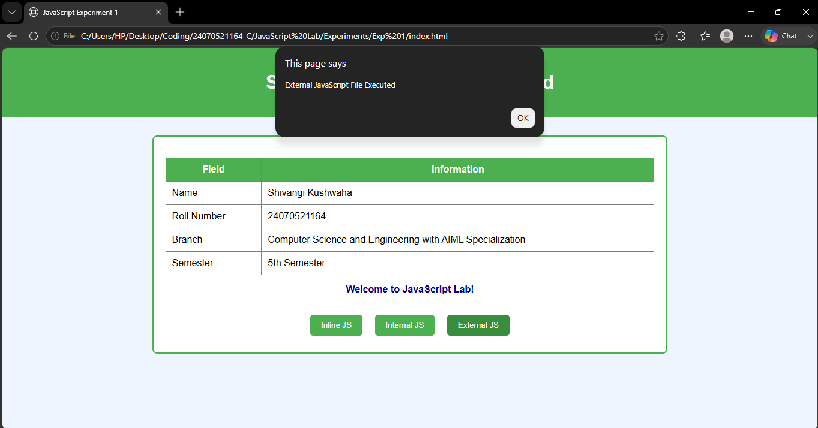

Result / Conclusion :-
The experiment was successfully performed. Different types of JavaScript (Inline, Internal, and External) were implemented successfully. Console methods were used to display debugging messages, and a webpage displaying student information with a welcome message was created successfully.

CASE STUDY -01

Aim : Create a webpage for college department and link the student information page with it and write a javascript program to display "Welcome to SIT Nagpur" in an alert box.

Software Tools required :
- Visual Studio Code (VS Code)
- Google Chrome / Any Web Browser
- HTML
- JavaScript

Code :
Department.html
<!DOCTYPE html>
<html lang="en">
<head>
<meta charset="UTF-8">
<meta name="viewport" content="width=device-width, initial-scale=1.0">
<title>SIT Nagpur - CSE Department</title>
<link rel="stylesheet" href="style.css">
</head>

<body>

<header>

<div class="logo-section">
<img src="images/sit-logo.png" class="logo">
<h2>Symbiosis Institute of Technology, Nagpur</h2>
</div>

<nav>
<a href="#">Home</a>
<a href="#">Department</a>
<a href="#">Faculty</a>
<a href="student.html">Student</a>
</nav>

</header>

<section class="hero">

<div class="hero-text">

<h1>Department of Computer Science & Engineering</h1>

<p>
Empowering students with excellence in Artificial Intelligence,
Cyber Security, Cloud Computing, Data Science and Software Engineering.
</p>

<a href="student.html" class="btn">
View Student Information
</a>

</div>

<div class="hero-image">

<img src="https://cdn-icons-png.flaticon.com/512/3135/3135755.png">

</div>

</section>

<section class="cards">

<div class="card">
<h2>💻 Modern Labs</h2>
<p>High-end laboratories equipped with the latest software and hardware.</p>
</div>

<div class="card">
<h2>👨‍🏫 Expert Faculty</h2>
<p>Experienced professors with strong academic and industry backgrounds.</p>
</div>

<div class="card">
<h2>🚀 Placements</h2>
<p>Excellent placement opportunities with leading companies.</p>
</div>

<div class="card">
<h2>📚 Research</h2>
<p>Innovation through research projects and technical competitions.</p>
</div>

</section>

<section class="stats">

<div>
<h1>25+</h1>
<p>Faculty Members</p>
</div>

<div>
<h1>600+</h1>
<p>Students</p>
</div>

<div>
<h1>15+</h1>
<p>Labs</p>
</div>

<div>
<h1>95%</h1>
<p>Placement Rate</p>
</div>

</section>

<script src="script.js"></script>

</body>
</html>

Script.js
alert("Welcome to SIT Nagpur");

student.html
<!DOCTYPE html>
<html lang="en">
<head>

<meta charset="UTF-8">

<meta name="viewport" content="width=device-width, initial-scale=1.0">

<title>Student Information</title>

<link rel="stylesheet" href="style.css">

</head>

<body>

<header>

<div class="logo-section">

<img src="images/sit-logo.png" class="logo">

<h2>Symbiosis Institute of Technology</h2>

</div>

<nav>

<a href="department.html">Department</a>

</nav>

</header>

<div class="student-container">

<div class="left">

<img src="https://cdn-icons-png.flaticon.com/512/3135/3135715.png">

<h2>Shivangi Kushwaha</h2>

<p>Computer Science Engineering</p>

</div>

<div class="right">

<h1>Student Information</h1>

<table>

<tr>

<th>Name</th>

<td>Shivangi Kushwaha</td>

</tr>

<tr>

<th>Roll Number</th>

<td>24070521164</td>

</tr>

<tr>

<th>Semester</th>

<td>5th</td>

</tr>

<tr>

<th>Division</th>

<td>C</td>

</tr>

<tr>

<th>Email</th>

<td>shivangi@gmail.com</td>

</tr>

<tr>

<th>College</th>

<td>SIT Nagpur</td>

</tr>

</table>

<a href="department.html" class="btn">

Back to Department

</a>

</div>

</div>

</body>

</html>

Style.css
*{
margin:0;
padding:0;
box-sizing:border-box;
font-family:Arial,sans-serif;
}

body{
background:#eef4f8;
}

header{
background:#002b5c;
color:white;
display:flex;
justify-content:space-between;
align-items:center;
padding:18px 60px;
}

.logo{

width:120px;
object-fit:contain;
margin-right:20px;
height : auto;

}

.logo-section{

display:flex;

align-items:center;

}

.logo-section h2{
font-size:34px;
font-weight:bold;
}

nav a{

color:white;

text-decoration:none;

margin-left:25px;

font-size:18px;

}

nav a:hover{

color:#ffd54f;

}

.hero{

display:flex;

justify-content:space-between;

align-items:center;

padding:70px;

background:white;

}

.hero-text{

width:55%;

}

.hero-text h1{

font-size:45px;

color:#002b5c;

margin-bottom:20px;

}

.hero-text p{

font-size:19px;

line-height:1.8;

margin-bottom:30px;

}

.hero-image img{

width:350px;

}

.btn{

display:inline-block;

padding:15px 35px;

background:#002b5c;

color:white;

text-decoration:none;

border-radius:30px;

transition:.3s;

}

.btn:hover{

background:#0056b3;

}

.cards{

display:grid;

grid-template-columns:repeat(2,1fr);

gap:30px;

padding:60px;

}

.card{

background:white;

padding:30px;

border-radius:15px;

box-shadow:0 10px 20px rgba(0,0,0,.1);

transition:.3s;

}

.card:hover{

transform:translateY(-8px);

}

.card h2{

margin-bottom:15px;

color:#002b5c;

}

.stats{

display:flex;

justify-content:space-around;

background:#002b5c;

color:white;

padding:40px;

text-align:center;

}

.stats h1{

font-size:45px;

}

.student-container{

display:flex;

width:80%;

margin:50px auto;

background:white;

box-shadow:0 10px 20px rgba(0,0,0,.1);

border-radius:20px;

overflow:hidden;

}

.left{

width:35%;

background:#002b5c;

color:white;

text-align:center;

padding:40px;

}

.left img{

width:170px;

margin-bottom:20px;

}

.right{

width:65%;

padding:40px;

}

.right h1{

color:#002b5c;

margin-bottom:20px;

}

table{

width:100%;

border-collapse:collapse;

margin-bottom:30px;

}

th{

background:#002b5c;

color:white;

padding:15px;

width:35%;

}

td{

padding:15px;

background:#f4f4f4;

}

table,th,td{

border:1px solid #ccc;

}

@media(max-width:900px){

.hero{

flex-direction:column;

text-align:center;

}

.hero-text{

width:100%;

margin-bottom:30px;

}

.cards{

grid-template-columns:1fr;

}

.student-container{

flex-direction:column;

}

.left,.right{

width:100%;

}

}

Output :

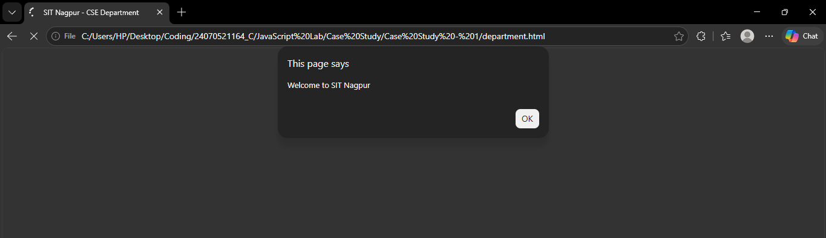

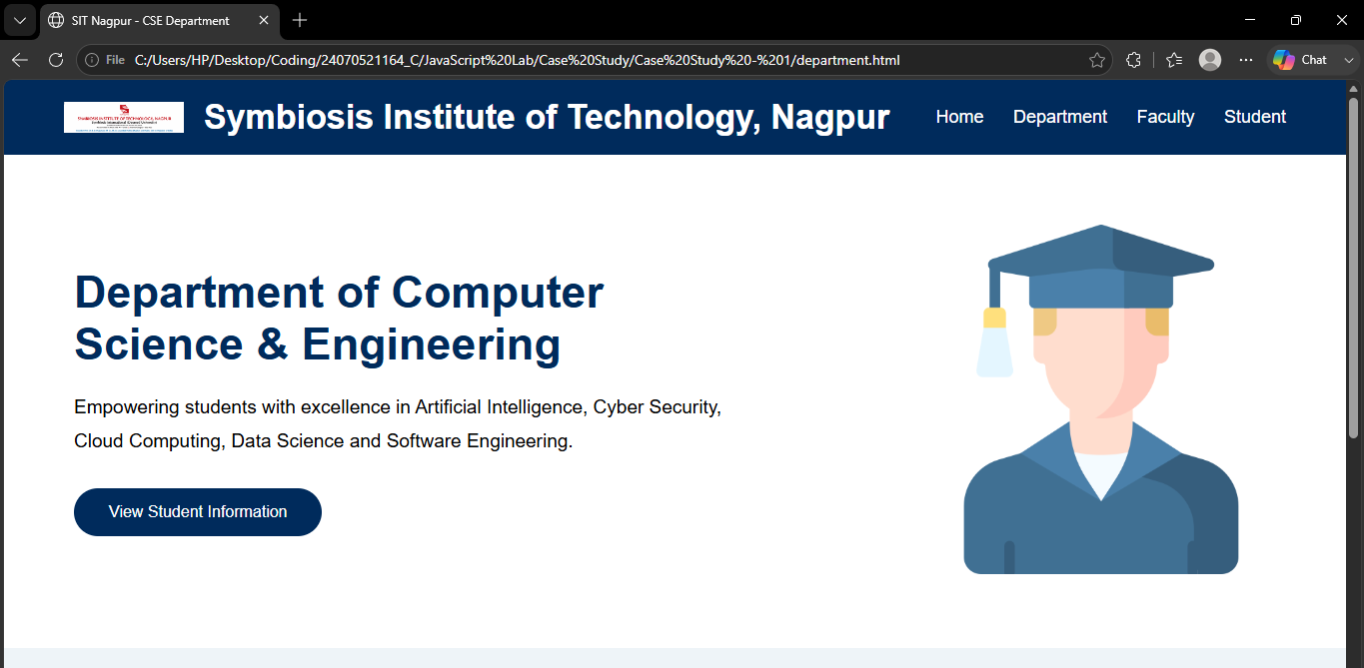

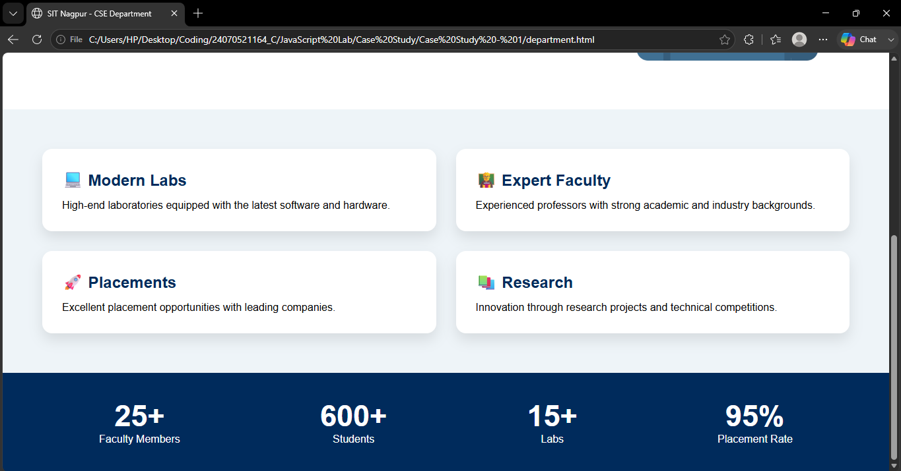

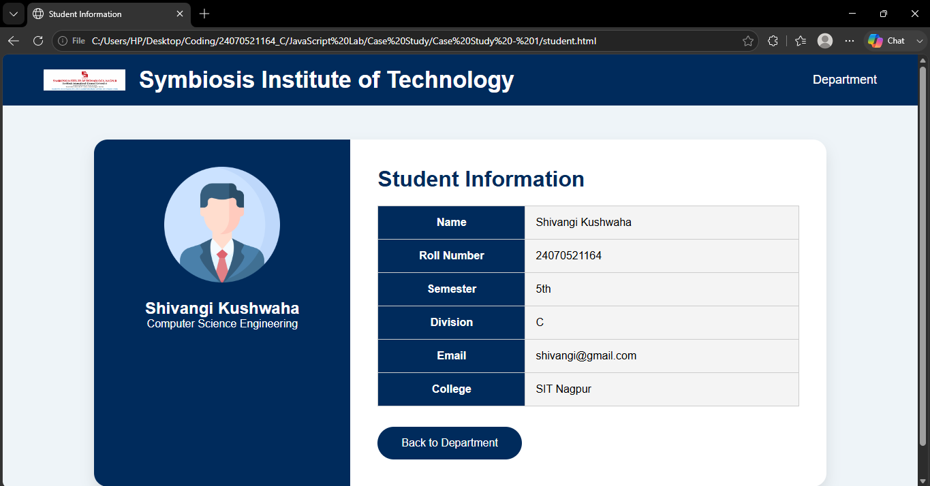

Result / Conclusion : Here we have performed webpage for college department and link the student information page with it and wrote a javascript program to display "Welcome to SIT Nagpur" in an alert box.

Experiment No – 2
Title / Aim :- Use var, let, const, and demonstrate basic features like template literals and destructuring; build a billing calculator with user input.
Software/Tools Required :-
- Visual Studio Code (VS Code)
- Google Chrome / Any Web Browser
- HTML
- JavaScript

CODE :-
<!DOCTYPE html>
<html lang="en">
<head>
<meta charset="UTF-8">
<meta name="viewport" content="width=device-width, initial-scale=1.0">
<title>TechZone Computer Store</title>

<style>

*{
margin:0;
padding:0;
box-sizing:border-box;
font-family:'Segoe UI',sans-serif;
}

body{

min-height:100vh;

display:flex;
justify-content:center;
align-items:center;

background:
linear-gradient(rgba(0,0,0,.15),rgba(0,0,0,.15)),
url("https://encrypted-tbn0.gstatic.com/images?q=tbn:ANd9GcSjkHFxkp-v2_11nBsAKTZihC1yr9yPB1q_zngMHVYPVw&s=10");

background-size:cover;
background-position:center;

}

/* Animated Grid */

body::before{

content:"";

position:absolute;

width:100%;
height:100%;

background-image:

linear-gradient(rgba(255,255,255,.04) 1px,transparent 1px),

linear-gradient(90deg,rgba(255,255,255,.04) 1px,transparent 1px);

background-size:35px 35px;

}

/* RGB Border */

.card{

width:500px;

background:#111827;

border-radius:20px;

padding:4px;

background:linear-gradient(
45deg,
#00e5ff,
#2979ff,
#00c853,
#ffea00,
#ff1744,
#00e5ff);

background-size:500%;

animation:rgb 8s linear infinite;

position:relative;

}

@keyframes rgb{

0%{background-position:0%}

100%{background-position:500%}

}

.inner{

background:#111827;

border-radius:18px;

overflow:hidden;

color:white;

}

/* Header */

.header{

padding:25px;

text-align:center;

background:#1f2937;

border-bottom:2px solid #00e5ff;

}

.logo{

font-size:55px;

}

.header h1{

margin-top:10px;

color:#00e5ff;

}

.header p{

color:#cbd5e1;

margin-top:8px;

}

/* Chip */

.chip{

display:inline-block;

margin-top:15px;

padding:8px 18px;

background:#00e5ff;

color:#111827;

border-radius:20px;

font-weight:bold;

}

/* Content */

.content{

padding:28px;

}

.row{

display:flex;

justify-content:space-between;

padding:15px 0;

border-bottom:1px solid #374151;

}

.label{

color:#00e5ff;

font-weight:bold;

}

.summary{

margin-top:20px;

}

.box{

display:flex;

justify-content:space-between;

padding:14px;

margin:10px 0;

background:#1f2937;

border-left:5px solid #00e5ff;

border-radius:8px;

}

/* Total */

.total{

margin-top:18px;

display:flex;

justify-content:space-between;

background:#00e5ff;

color:#111827;

padding:18px;

font-size:24px;

font-weight:bold;

border-radius:10px;

box-shadow:0 0 20px #00e5ff;

}

.footer{

text-align:center;

padding:20px;

color:#94a3b8;

}

.footer strong{

color:#00e5ff;

}

.inner:hover{

transform:translateY(-5px);

transition:.4s;

}

</style>

</head>

<body>

<div class="card">

<div class="inner">

<div class="header">

<div class="logo">

💻

</div>

<h1>TECHZONE</h1>

<p>Computer & Gaming Store</p>

<div class="chip">

✔ WARRANTY INCLUDED

</div>

</div>

<div id="receipt"></div>

<div class="footer">

<strong>Thank You!</strong>

<br>

</div>

</div>

</div>

<script>

// var

var customerName=prompt("Enter Customer Name");

// let

let productName=prompt("Enter Product Name");

let price=Number(prompt("Enter Product Price"));

let quantity=Number(prompt("Enter Quantity"));

// const

const GST_RATE=0.18;

// Calculation

let subtotal=price*quantity;

let gst=subtotal*GST_RATE;

let total=subtotal+gst;

// Object

const bill={

customerName,
productName,
price,
quantity,
subtotal,
gst,
total

};

// Destructuring

const{

customerName:cname,

productName:pname,

price:pprice,

quantity:qty,

subtotal:sub,

gst:gstAmount,

total:grandTotal

}=bill;

// Template Literals

document.getElementById("receipt").innerHTML=`

<div class="content">

<div class="row">

<span class="label">👤 Customer</span>

<span>${cname}</span>

</div>

<div class="row">

<span class="label">💻 Product</span>

<span>${pname}</span>

</div>

<div class="row">

<span class="label">💰 Price</span>

<span>₹${pprice.toFixed(2)}</span>

</div>

<div class="row">

<span class="label">📦 Quantity</span>

<span>${qty}</span>

</div>

<div class="summary">

<div class="box">

<span>Subtotal</span>

<span>₹${sub.toFixed(2)}</span>

</div>

<div class="box">

<span>GST (18%)</span>

<span>₹${gstAmount.toFixed(2)}</span>

</div>

<div class="total">

<span>Total</span>

<span>₹${grandTotal.toFixed(2)}</span>

</div>

</div>

</div>

`;

</script>

</body>
</html>

OUTPUT:-

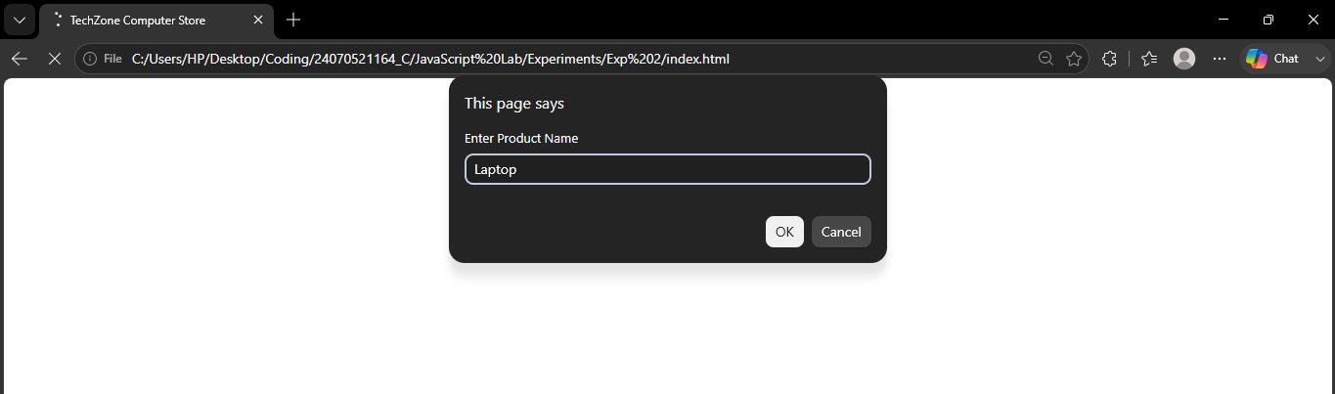

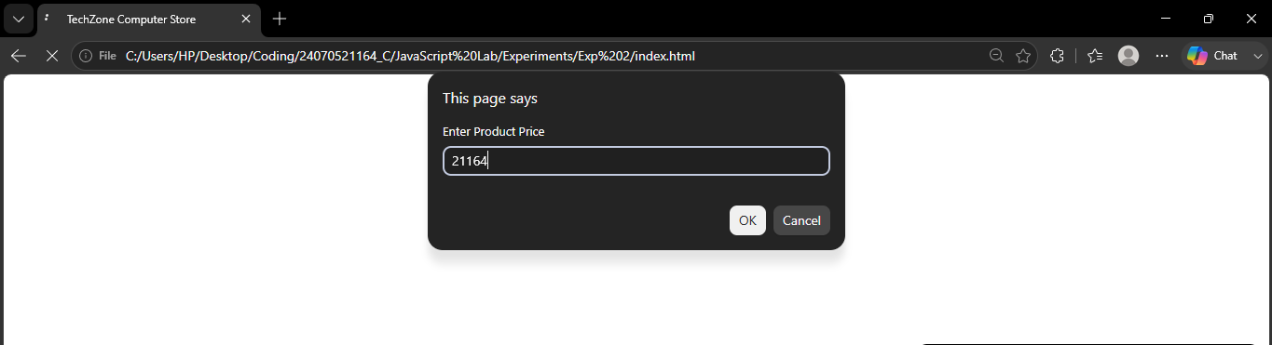
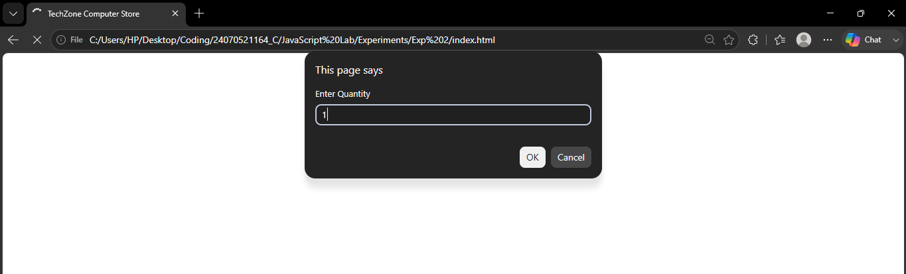

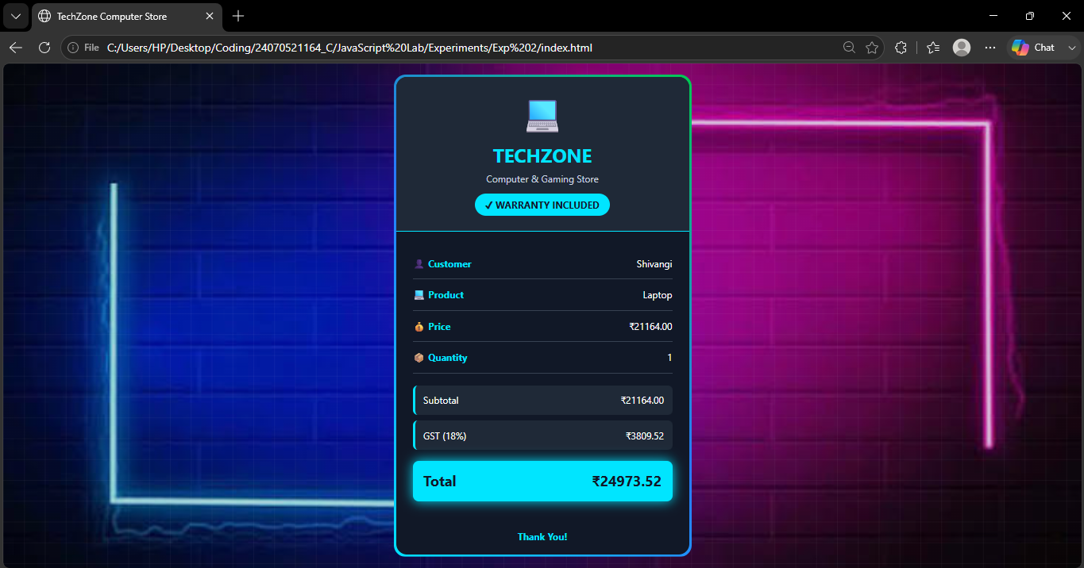

Result / Conclusion :- The Billing Calculator was successfully developed using HTML, CSS, and JavaScript. The program correctly accepts user input, calculates the subtotal, GST (18%), and total amount, and displays a well-formatted billing receipt. This experiment enhanced the understanding of JavaScript concepts such as variable declarations, template literals, object destructuring, user input handling, and DOM manipulation while creating an interactive web application.
CASE STUDY -02

Aim : To design and implement an interactive online shopping billing system using HTML, CSS, and HTML5 that accepts customer and product details and automatically calculates the final payable amount.

Software / Tool Requried :
- Visual Studio Code (VS Code)
- Google Chrome / Any Web Browser
- HTML
- JavaScript

CODE :

Index.html

<!DOCTYPE html>
<html lang="en">
<head>
<meta charset="UTF-8">
<meta name="viewport" content="width=device-width, initial-scale=1.0">
<title>Fruit-Frootie - Smart Billing</title>
<link rel="stylesheet" href="style.css">
<link href="https://fonts.googleapis.com/css2?family=Roboto+Mono:wght@400;500;700&display=swap" rel="stylesheet">
<link rel="stylesheet"
href="https://cdnjs.cloudflare.com/ajax/libs/font-awesome/6.5.2/css/all.min.css">
</head>
<body>
<div class="container">
<header>
<div class="logo">
<h1>
<i class="fa-solid fa-cart-shopping"></i>
<Fruit-Frootie>Fruit-Frootie</Fruit-Frootie>
</h1>
<p>Fresh Fruits</p>
</div>
<div class="title">
<h2>
<i class="fa-solid fa-receipt"></i>
Smart Billing
</h2>
</div>
</header>

<hr>

<!-- ================= MAIN ================= -->

<main>

<!-- ================= LEFT PANEL ================= -->

<section class="left-panel">

<h2>
🍎 Product Info
</h2>

<form id="billingForm">

<div class="input-group">

<label>
<i class="fa-solid fa-user"></i>
Customer Name
</label>

<input
type="text"
id="customerName"
placeholder="Enter customer name">
</div>

<div class="input-group">

<label>
<i class="fa-solid fa-mobile-screen-button"></i>
Mobile Number
</label>

<input
type="tel"
id="mobile"
maxlength="10"
placeholder="10 digit mobile number">

</div>

<div class="input-group">

<label>
<i class="fa-solid fa-cart-shopping"></i>
Product Name
</label>

<select id="product">

<option value="">Select Product</option>

<option value="Apple"
data-rate="250">
Apple
</option>

<option value="Strawberry"
data-rate="250">
Strawberry
</option>

<option value="Cherry"
data-rate="250">
Cherry
</option>

<option value="Banana"
data-rate="80">
Banana
</option>

<option value="Mango"
data-rate="180">
Mango
</option>

</select>

</div>

<div class="input-group">

<label>
<i class="fa-solid fa-weight-hanging"></i>
Quantity (Kg)
</label>

<input
type="number"
id="quantity"
min="1"
placeholder="Enter quantity">

</div>

<div class="input-group">

<label>
<i class="fa-solid fa-sack-dollar"></i>
Rate / Kg
</label>

<input
type="number"
id="rate"
readonly>

</div>

<div class="input-group">

<label>
<i class="fa-solid fa-star"></i>
Membership
</label>

<select id="member">

<option value="No">No</option>

<option value="Yes">Yes</option>

</select>
</div>
<div class="input-group">
<label>
<i class="fa-solid fa-credit-card"></i>
Payment Mode
</label>
<select id="payment">
<option>Cash</option>
<option>Card</option>
<option>UPI</option>
</select>
</div>
<div class="button-group">
<button
type="button"
id="calculateBtn">
Calculate Bill
</button>
<button
type="reset"
id="resetBtn">
Reset
</button>
</div>
</form>
</section>
<section class="right-panel">
<h2>
<i class="fa-solid fa-file-invoice"></i>
Invoice Summary
</h2>
<div class="invoice">
<p>
Invoice #
<span id="invoiceNo">
INV-1001
</span>
</p>
<p>
Date
<span id="currentDate"></span>
</p>
<p>
Customer
<span id="outCustomer">-</span>
</p>
<p>
Product
<span id="outProduct">-</span>
</p>
<hr>
<p>
Quantity
<span id="outQty">0 Kg</span>
</p>
<p>
Rate
<span id="outRate">₹0</span>
</p>
<hr>
<p>
Subtotal
<span id="subtotal">₹0</span>
</p>
<p>
Discount
<span id="discount">₹0</span>
</p>
<p>
GST (5%)
<span id="gst">₹0</span>
</p>
<p>
Packing
<span id="packing">₹50</span>
</p>
<hr>
<h3>
TOTAL
<span id="total">
₹0
</span>
</h3>
</div>
</section>
</main>
</div>
<script src="script.js"></script>
</body>
</html>

Script.js
const invoiceNo = document.getElementById("invoiceNo");

// Date
const currentDate = document.getElementById("currentDate");

// Inputs
const customerName = document.getElementById("customerName");
const mobile = document.getElementById("mobile");
const product = document.getElementById("product");
const quantity = document.getElementById("quantity");
const rate = document.getElementById("rate");
const member = document.getElementById("member");
const payment = document.getElementById("payment");

// Buttons
const calculateBtn = document.getElementById("calculateBtn");
const resetBtn = document.getElementById("resetBtn");

// Invoice Output
const outCustomer = document.getElementById("outCustomer");
const outProduct = document.getElementById("outProduct");
const outQty = document.getElementById("outQty");
const outRate = document.getElementById("outRate");

const subtotal = document.getElementById("subtotal");
const discount = document.getElementById("discount");
const gst = document.getElementById("gst");
const packing = document.getElementById("packing");
const total = document.getElementById("total");

// ======================================
// Generate Invoice Number
// ======================================

invoiceNo.textContent =
"INV-" + Math.floor(1000 + Math.random() * 9000);

// ======================================
// Current Date
// ======================================

const today = new Date();

currentDate.textContent =
today.toLocaleDateString("en-GB", {
day: "numeric",
month: "long",
year: "numeric"
});

// ======================================
// Product Rate
// ======================================

product.addEventListener("change", () => {

const selected =
product.options[product.selectedIndex];

const price =
selected.getAttribute("data-rate");

rate.value = price ? price : "";

});

// ======================================
// Calculate Bill
// ======================================

calculateBtn.addEventListener("click", () => {

// Validation

if (customerName.value.trim() === "") {
alert("Enter Customer Name");
customerName.focus();
return;
}

if (!/^[0-9]{10}$/.test(mobile.value)) {
alert("Enter Valid Mobile Number");
mobile.focus();
return;
}

if (product.value === "") {
alert("Select Product");
return;
}

if (quantity.value === "" || quantity.value <= 0) {
alert("Enter Quantity");
quantity.focus();
return;
}

// Values

const qty = Number(quantity.value);

const price = Number(rate.value);

const sub = qty * price;

let discountAmount = 0;

if (member.value === "Yes") {
discountAmount = sub * 0.10;
}

const afterDiscount =
sub - discountAmount;

const gstAmount =
afterDiscount * 0.05;

const packingCharge = 50;

const finalTotal =
afterDiscount + gstAmount + packingCharge;

// Invoice Output

outCustomer.textContent =
customerName.value;

outProduct.textContent =
product.value;

outQty.textContent =
qty + " Kg";

outRate.textContent =
"₹" + price.toFixed(2);

subtotal.textContent =
"₹" + sub.toFixed(2);

discount.textContent =
"₹" + discountAmount.toFixed(2);

gst.textContent =
"₹" + gstAmount.toFixed(2);

packing.textContent =
"₹" + packingCharge.toFixed(2);

total.textContent =
"₹" + finalTotal.toFixed(2);

});

// ======================================
// Reset
// ======================================

resetBtn.addEventListener("click", () => {

rate.value = "";

outCustomer.textContent = "-";
outProduct.textContent = "-";
outQty.textContent = "0 Kg";
outRate.textContent = "₹0";

subtotal.textContent = "₹0";
discount.textContent = "₹0";
gst.textContent = "₹0";
packing.textContent = "₹50";
total.textContent = "₹0";

invoiceNo.textContent =
"INV-" + Math.floor(1000 + Math.random() * 9000);

currentDate.textContent =
new Date().toLocaleDateString("en-GB", {
day: "numeric",
month: "long",
year: "numeric"
});

});

// ======================================
// Print Invoice
// ======================================

function printInvoice() {
window.print();
}

Style.css

*{
margin:0;
padding:0;
box-sizing:border-box;
font-family:'Times New Roman', monospace;
}

body{
margin: 0;
padding: 40px 20px;
font-family: 'Roboto Mono', monospace;

background: url("images/background.jpg") no-repeat center center fixed;
background-size: cover;

display: flex;
justify-content: center;
align-items: center;

min-height: 100vh;
color: white;
}
.container{
width: 1200px;
max-width: 100%;

background: rgba(0, 0, 0, 0.65);

backdrop-filter: blur(12px);
-webkit-backdrop-filter: blur(12px);

border: 1px solid rgba(255,255,255,0.2);

border-radius: 15px;

padding: 35px;

box-shadow: 0 10px 30px rgba(0,0,0,0.5);
}

header{
display:flex;
justify-content:space-between;
align-items:flex-start;
margin-bottom:25px;
}

.logo h1{
font-size:32px;
margin-bottom:12px;
color:#ffffff;
}

.logo p{
font-size:18px;
color:#dddddd;
font-weight:500;
}

.title h2{
font-size:30px;
color:#ffffff;
}

hr{
border:none;
border-top:2px solid #8a8a8a;
margin:25px 0;
}

main{
display:grid;
grid-template-columns:1fr 1fr;
gap:70px;
}

/* ===========================
PANEL TITLES
=========================== */

.left-panel h2,
.right-panel h2{
margin-bottom:25px;
font-size:28px;
}

/* ===========================
FORM
=========================== */

#billingForm,
.invoice{
background: rgba(255,255,255,0.05);

border: 1px solid rgba(255,255,255,0.2);

border-radius: 12px;

padding: 30px;

backdrop-filter: blur(8px);
}

.input-group{
margin-bottom:22px;
}

.input-group label{
display:block;
font-size:20px;
margin-bottom:8px;
font-weight:bold;
}

.input-group label i{
width:28px;
}

.input-group input,
.input-group select{

width:100%;

padding:13px;

font-size:18px;

color:rgb(10, 10, 10);

background:rgba(255,255,255,0.08);

border:1px solid rgba(255,255,255,0.25);

border-radius:8px;

outline:none;

transition:.3s;
}

.input-group input:focus,
.input-group select:focus{

border-color:#4CAF50;

box-shadow:0 0 12px rgba(76,175,80,.4);

}
/* ===========================
BUTTONS
=========================== */

.button-group{
margin-top:35px;
display:flex;
gap:18px;
}

.button-group button{

flex:1;

padding:15px;

font-size:18px;

color:white;

background:#4CAF50;

border:none;

border-radius:8px;

cursor:pointer;

transition:.3s;
}

.button-group button:hover{

transform:translateY(-3px);

background:#2E7D32;

box-shadow:0 8px 20px rgba(76,175,80,.4);

}

#billingForm:hover,
.invoice:hover{

transform:translateY(-5px);

transition:.3s;

box-shadow:0 10px 25px rgba(0,0,0,.4);

}
/* ===========================
INVOICE
=========================== */

.invoice{
border:2px solid #d9d9d9;
padding:30px;
}

.invoice p{
display:flex;
justify-content:space-between;
margin:18px 0;
font-size:20px;
}

.invoice h3{
display:flex;
justify-content:space-between;
margin-top:25px;
font-size:30px;
color:#FFD54F;
}

.invoice hr{
margin:20px 0;
border-top:1px dashed #999;
}

/* ===========================
FOOTER
=========================== */

footer{
margin-top:45px;
text-align:center;
font-size:22px;
font-weight:bold;
}

/* ===========================
INPUT PLACEHOLDER
=========================== */

::placeholder{
color:#b8b8b8;
}

/* ===========================
SCROLLBAR
=========================== */

::-webkit-scrollbar{
width:10px;
}

::-webkit-scrollbar-track{
background:#222;
}

::-webkit-scrollbar-thumb{
background:#555;
}

::-webkit-scrollbar-thumb:hover{
background:#777;
}

/* ===========================
RESPONSIVE
=========================== */

@media(max-width:900px){

header{
flex-direction:column;
gap:20px;
}

main{
grid-template-columns:1fr;
}

.button-group{
flex-direction:column;
}

.logo h1{
font-size:28px;
}

.title h2{
font-size:26px;
}

.left-panel h2,
.right-panel h2{
font-size:24px;
}

.invoice p{
font-size:18px;
}

.invoice h3{
font-size:26px;
}

}

@media(max-width:600px){

body{
padding:20px 10px;
}

#billingForm,
.invoice{
padding:20px;
}

.input-group label{
font-size:18px;
}

.input-group input,
.input-group select{
font-size:16px;
}

footer{
font-size:18px;
}

}

Output :

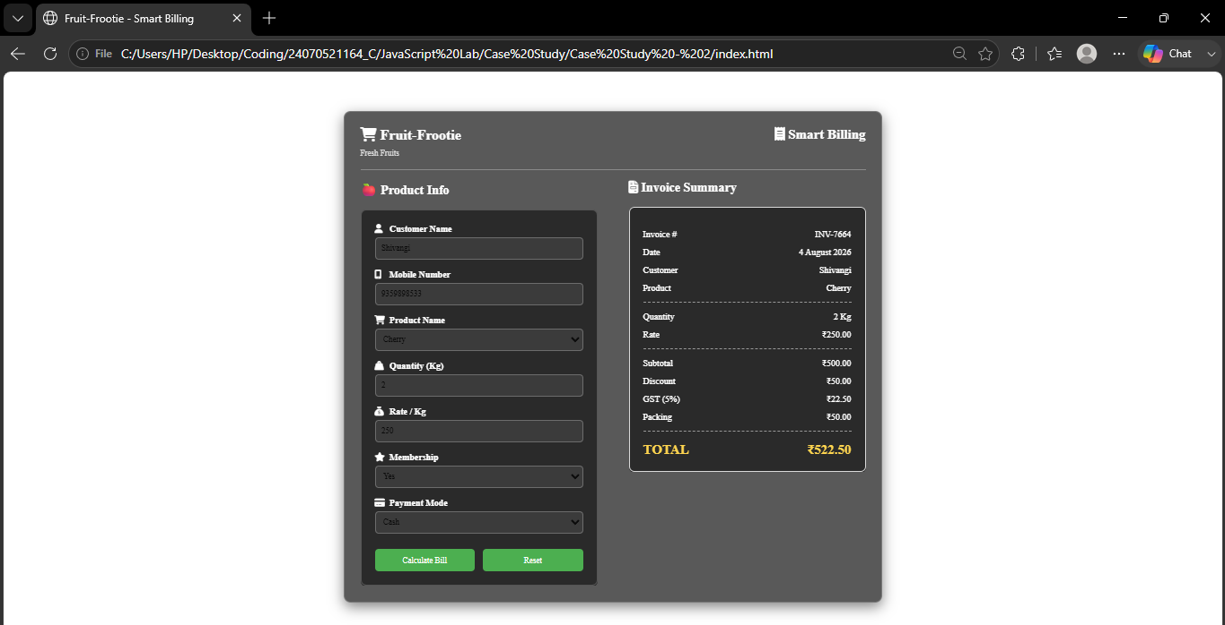

Result/ Conclusion : The online shopping billing system was successfully designed using HTML, CSS, and HTML5. It generates an invoice by calculating the final bill using predefined discount, GST, and packing charges. The project provides a simple, accurate, and user-friendly shopping experience while demonstrating fundamental web development concepts.

Experiment No – 3
Title / Aim :- Implement control structures and form validation; create a grading system based on user-entered marks.
Software/Tools Required :-
- Visual Studio Code (VS Code)
- Google Chrome / Any Web Browser
- HTML
- JavaScript

CODE :-
Index.html
<!DOCTYPE html>
<html lang="en">
<head>
<meta charset="UTF-8">
<meta name="viewport" content="width=device-width, initial-scale=1.0">
<title>Student Marks Entry</title>
<link rel="stylesheet" href="style.css">
</head>

<body>

<div class="container">

<h1>Student Grading System</h1>

<form id="marksForm">

<label>Student Name</label>
<input type="text" id="name" required>

<label>Computer Networks</label>
<input type="number" id="cn" min="0" max="100" required>

<label>Compiler Construction</label>
<input type="number" id="cc" min="0" max="100" required>

<label>Data Compression</label>
<input type="number" id="dc" min="0" max="100" required>

<label>Agentic AI</label>
<input type="number" id="ai" min="0" max="100" required>

<label>Flexi-credit JavaScript</label>
<input type="number" id="js" min="0" max="100" required>

<label>Soft Computing (Specialization)</label>
<input type="number" id="sc" min="0" max="100" required>

<button type="submit">Generate Grade Card</button>

</form>

</div>

<script src="script.js"></script>

</body>
</html>

Result.html

<!DOCTYPE html>
<html lang="en">

<head>
<meta charset="UTF-8">
<title>Grade Card</title>
<link rel="stylesheet" href="style.css">
</head>

<body>

<div class="container">

<h1>Student Grade Card</h1>

<h2 id="studentName"></h2>

<table>

<tr>
<th>Subject</th>
<th>Marks</th>
<th>Grade</th>
</tr>

<tbody id="tableData"></tbody>

</table>

<h3 id="percentage"></h3>
<h3 id="overallGrade"></h3>

<a href="index.html">
<button>Back</button>
</a>

</div>

<script>

const data = JSON.parse(localStorage.getItem("student"));

document.getElementById("studentName").innerHTML =
"Student : " + data.name;

const subjects = [
["Computer Networks",data.cn],
["Compiler Construction",data.cc],
["Data Compression",data.dc],
["Agentic AI",data.ai],
["Flexi-credit JavaScript",data.js],
["Soft Computing",data.sc]
];

function grade(mark){

if(mark>=90) return "A+";
else if(mark>=80) return "A";
else if(mark>=70) return "B";
else if(mark>=60) return "C";
else if(mark>=50) return "D";
else return "F";

}

let total=0;

let output="";

subjects.forEach(subject=>{

total+=Number(subject[1]);

output+=`
<tr>
<td>${subject[0]}</td>
<td>${subject[1]}</td>
<td>${grade(subject[1])}</td>
</tr>
`;

});

document.getElementById("tableData").innerHTML=output;

let percentage=(total/600*100).toFixed(2);

document.getElementById("percentage").innerHTML=
"Percentage : "+percentage+"%";

document.getElementById("overallGrade").innerHTML=
"Overall Grade : "+grade(percentage);

</script>

</body>
</html>

Script.js
document.getElementById("marksForm").addEventListener("submit",function(e){

e.preventDefault();

let student={

name:document.getElementById("name").value,

cn:Number(document.getElementById("cn").value),

cc:Number(document.getElementById("cc").value),

dc:Number(document.getElementById("dc").value),

ai:Number(document.getElementById("ai").value),

js:Number(document.getElementById("js").value),

sc:Number(document.getElementById("sc").value)

};

for(let key in student){

if(key!="name"){

if(student[key]<0 || student[key]>100){

alert("Marks should be between 0 and 100");

return;

}

}

}

localStorage.setItem("student",JSON.stringify(student));

window.location.href="result.html";

});

Style.css
body{

font-family:Arial, Helvetica, sans-serif;
background:rgba(87, 168, 39, 0.6);

}

.container{

width:900px;
margin:40px auto;
background:rgba(87, 168, 39, 0.6);
padding:35px;
border-radius:20px;
box-shadow:50 0 15px rgba(0,0,0,.2);

}

h1,h2,h3{

text-align:center;

}

label{

display:block;
margin-top:15px;
font-weight:bold;

}

input{

width:95%;
padding:10px;
margin-top:5px;
border-radius:5px;
border:1px solid rgb(131, 129, 129);

}

button{

margin-top:25px;
width:100%;
padding:12px;
background:#2cac41;
color:white;
border:none;
border-radius:5px;
cursor:pointer;
font-size:16px;

}

button:hover{

background:#005ec7;

}

table{

width:100%;
border-collapse:collapse;
margin-top:25px;

}

table th{

background:#0078ff;
color:white;

}

table th,
table td{

border:1px solid rgb(0, 0, 0);
padding:10px;
text-align:center;

}

OUTPUT:-
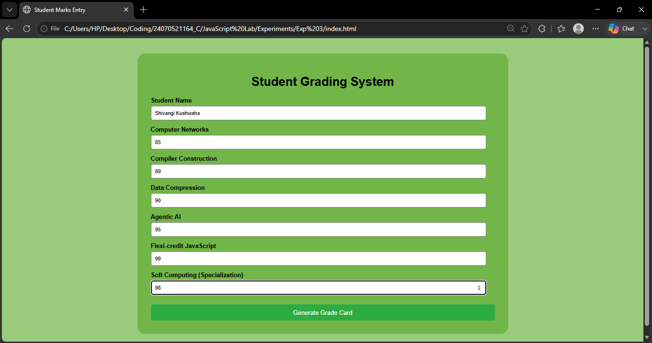

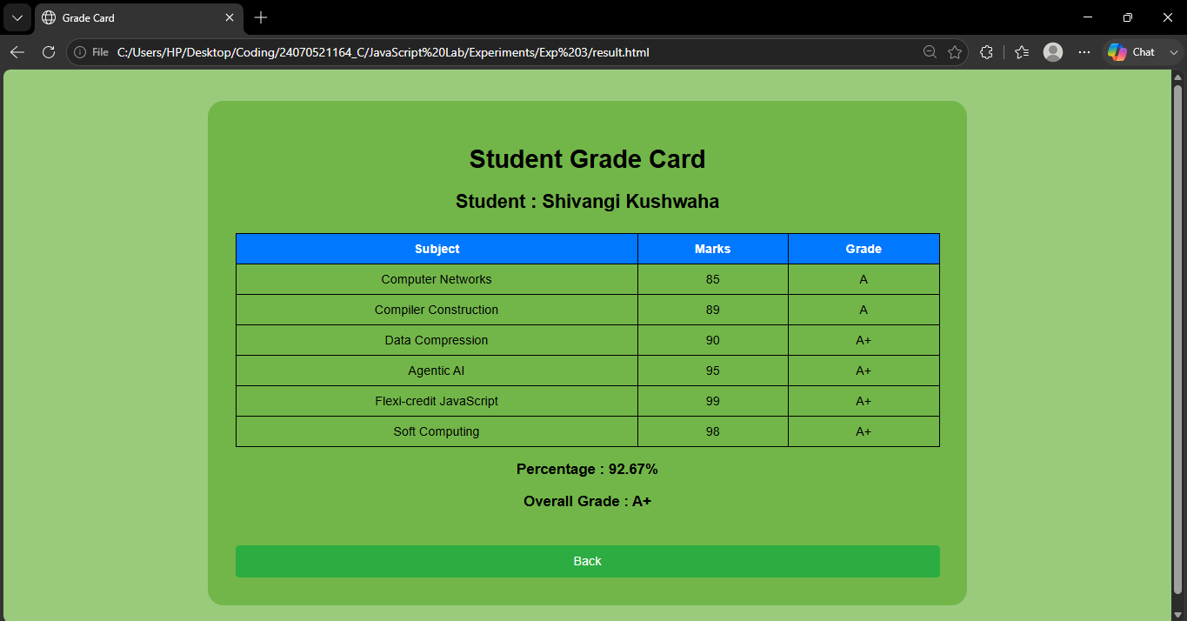

Result / Conclusion :-
The Student Grading System was successfully implemented using HTML and JavaScript. The system validated user input, calculated grades using control structures, and generated a clear grade card with subject-wise results, percentage, and overall grade. This project demonstrated the practical application of form validation, decision-making statements, and basic web development concepts.

CASE STUDY -03
Aim : Student Grading System with Login Authentication and Form Validation using
HTML, CSS, and JavaScript
Sodtware / Tools Required :
- Visual Studio Code (VS Code)
- Google Chrome / Any Web Browser
- HTML
- JavaScript

CODE :
Index.html
<!DOCTYPE html>
<html lang="en">
<head>
<meta charset="UTF-8">
<meta name="viewport" content="width=device-width, initial-scale=1.0">
<title>Student Login</title>
<link rel="stylesheet" href="style.css">
</head>
<body>

<div class="container">

<div class="card">
<h1>Student Login</h1>
<p class="subtitle">Please enter your details to continue to the grading portal.</p>

<form id="loginForm">
<label>Student Name</label>
<input type="text" id="name" required>

<label>PRN</label>
<input type="text" id="prn" required>

<label>Password</label>
<input type="password" id="password" required>

<button type="submit">Login</button>
</form>
</div>

</div>

<script src="script.js"></script>

</body>
</html>

Marks.html
<!DOCTYPE html>
<html lang="en">
<head>
<meta charset="UTF-8">
<meta name="viewport" content="width=device-width, initial-scale=1.0">
<title>Student Marks Entry</title>
<link rel="stylesheet" href="style.css">
</head>
<body>

<div class="container">

<div class="card">
<h1>Student Marks Entry</h1>
<p class="subtitle">Enter the marks for each subject to generate the grade card.</p>

<form id="marksForm">
<label>Computer Networks</label>
<input type="number" id="cn" min="0" max="100" required>

<label>Compiler Construction</label>
<input type="number" id="cc" min="0" max="100" required>

<label>Data Compression</label>
<input type="number" id="dc" min="0" max="100" required>

<label>Agentic AI</label>
<input type="number" id="ai" min="0" max="100" required>

<label>Flexi-credit JavaScript</label>
<input type="number" id="js" min="0" max="100" required>

<label>Soft Computing (Specialization)</label>
<input type="number" id="sc" min="0" max="100" required>

<button type="submit">Generate Grade Card</button>
</form>
</div>

</div>

<script src="script.js"></script>

</body>
</html>

Result.html
<!DOCTYPE html>
<html lang="en">
<head>
<meta charset="UTF-8">
<title>Grade Card</title>
<link rel="stylesheet" href="style.css">
</head>
<body>

<div class="container">

<div class="card">
<h1>Student Grade Card</h1>
<h2 id="studentName"></h2>
<p id="studentInfo" class="subtitle"></p>

<table>
<tr>
<th>Subject</th>
<th>Marks</th>
<th>Grade</th>
</tr>
<tbody id="tableData"></tbody>
</table>

<h3 id="percentage"></h3>
<h3 id="overallGrade"></h3>

<a href="index.html">
<button type="button">Back</button>
</a>
</div>

</div>

<script>
const data = JSON.parse(localStorage.getItem("student"));

if (!data) {
window.location.href = "index.html";
} else {
document.getElementById("studentName").innerHTML = "Student : " + data.name;
document.getElementById("studentInfo").innerHTML = "PRN : " + data.prn;

const subjects = [
["Computer Networks", data.cn],
["Compiler Construction", data.cc],
["Data Compression", data.dc],
["Agentic AI", data.ai],
["Flexi-credit JavaScript", data.js],
["Soft Computing", data.sc]
];

function grade(mark) {
if (mark >= 90) return "A+";
else if (mark >= 80) return "A";
else if (mark >= 70) return "B";
else if (mark >= 60) return "C";
else if (mark >= 50) return "D";
else return "F";
}

let total = 0;
let output = "";

subjects.forEach(subject => {
total += Number(subject[1]);
output += `
<tr>
<td>${subject[0]}</td>
<td>${subject[1]}</td>
<td>${grade(subject[1])}</td>
</tr>
`;
});

document.getElementById("tableData").innerHTML = output;

let percentage = (total / 600 * 100).toFixed(2);
document.getElementById("percentage").innerHTML = "Percentage : " + percentage + "%";
document.getElementById("overallGrade").innerHTML = "Overall Grade : " + grade(percentage);
}
</script>

</body>
</html>

Script.js
const loginForm = document.getElementById("loginForm");

if (loginForm) {
loginForm.addEventListener("submit", function (e) {
e.preventDefault();

const student = {
name: document.getElementById("name").value,
prn: document.getElementById("prn").value,
password: document.getElementById("password").value
};

localStorage.setItem("student", JSON.stringify(student));
window.location.href = "marks.html";
});
}

const marksForm = document.getElementById("marksForm");

if (marksForm) {
marksForm.addEventListener("submit", function (e) {
e.preventDefault();

let student = JSON.parse(localStorage.getItem("student")) || {};

student.cn = Number(document.getElementById("cn").value);
student.cc = Number(document.getElementById("cc").value);
student.dc = Number(document.getElementById("dc").value);
student.ai = Number(document.getElementById("ai").value);
student.js = Number(document.getElementById("js").value);
student.sc = Number(document.getElementById("sc").value);

for (let key in student) {
if (key !== "name" && key !== "prn" && key !== "password") {
if (student[key] < 0 || student[key] > 100) {
alert("Marks should be between 0 and 100");
return;
}
}
}

localStorage.setItem("student", JSON.stringify(student));
window.location.href = "result.html";
});
}

Style.css
body {
font-family: Arial, Helvetica, sans-serif;
background: linear-gradient(135deg, #e8f8e8, #7ed957);
margin: 0;
padding: 20px;
}

.container {
width: min(900px, 95%);
margin: 40px auto;
padding: 35px;
}

.card {
background: rgba(255, 255, 255, 0.95);
padding: 35px;
border-radius: 20px;
box-shadow: 0 10px 25px rgba(0, 0, 0, 0.2);
}

h1, h2, h3 {
text-align: center;
color: #1f5f2f;
}

.subtitle {
text-align: center;
color: #4f4f4f;
margin-bottom: 20px;
}

label {
display: block;
margin-top: 15px;
font-weight: bold;
color: #2d4d2f;
}

input {
width: 95%;
padding: 10px;
margin-top: 5px;
border-radius: 8px;
border: 1px solid #b7c9b4;
}

button {
margin-top: 25px;
width: 100%;
padding: 12px;
background: linear-gradient(135deg, #2cac41, #1f7d32);
color: white;
border: none;
border-radius: 8px;
cursor: pointer;
font-size: 16px;
}

button:hover {
background: linear-gradient(135deg, #1f7d32, #005ec7);
}

table {
width: 100%;
border-collapse: collapse;
margin-top: 25px;
}

table th {
background: #0078ff;
color: white;
}

table th,
table td {
border: 1px solid #b7c9b4;
padding: 10px;
text-align: center;
}

a {
text-decoration: none;
}

Output :
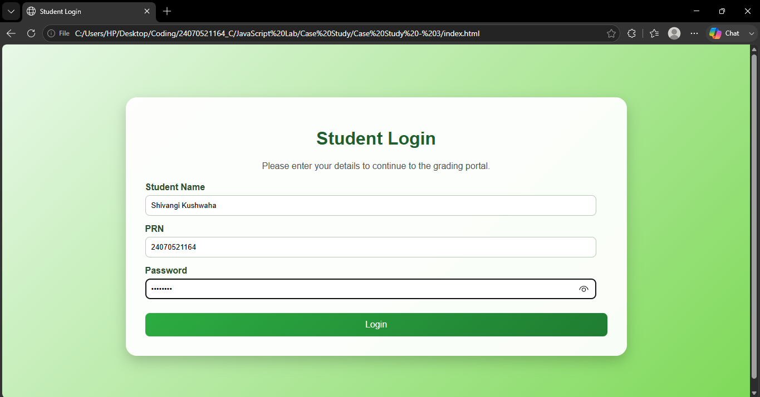

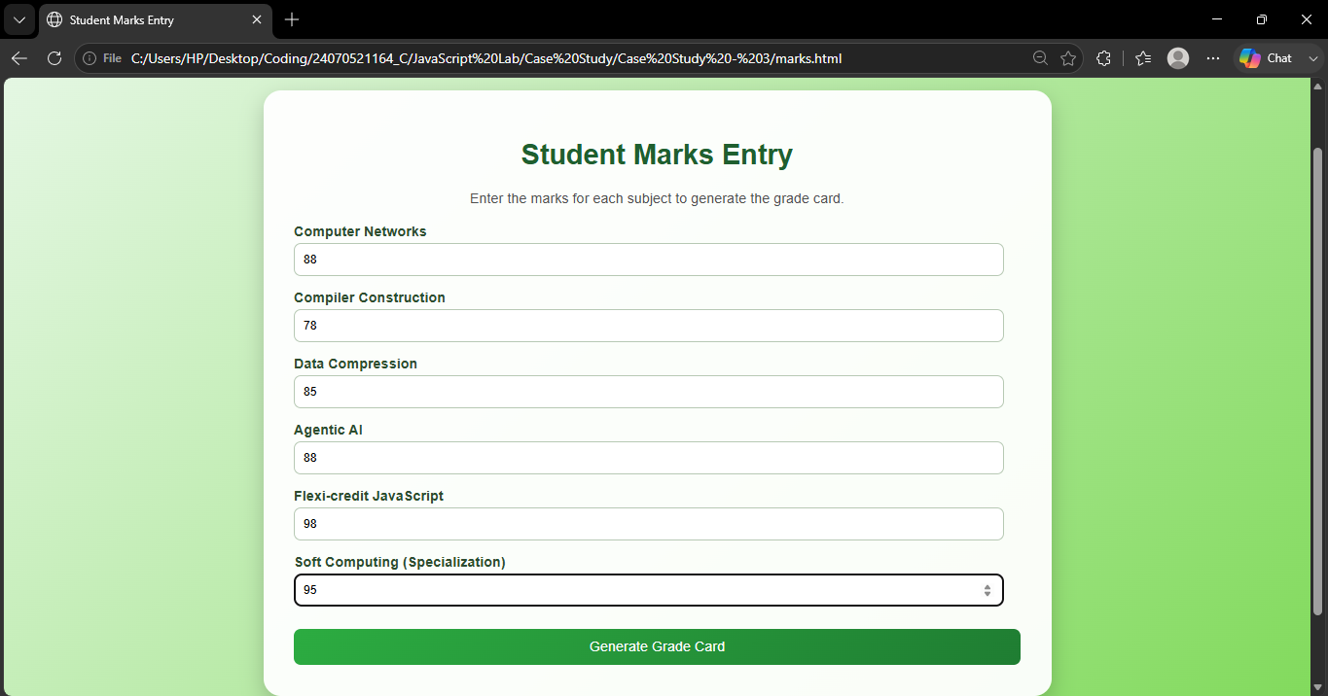

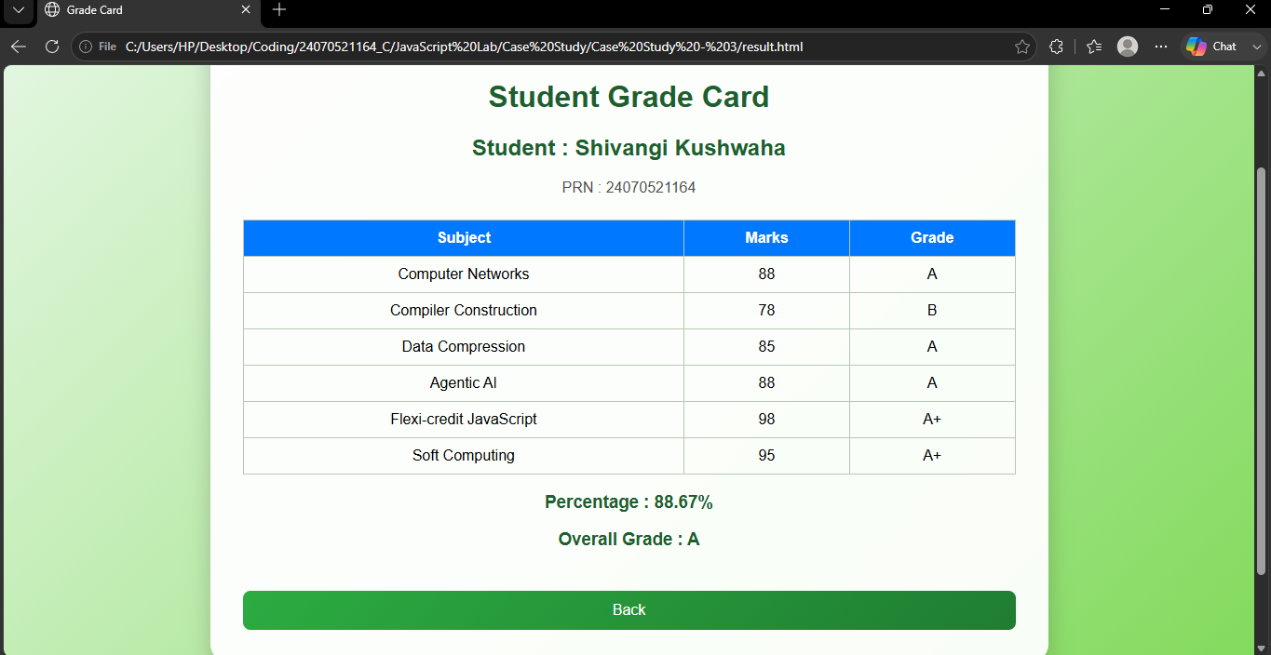

Result / Conclusion :
The Student Grading System was successfully implemented using HTML, CSS, and JavaScript with login authentication and form validation. The application securely verifies users, validates input data, and accurately calculates and displays student grades. It demonstrates the effective use of front-end web technologies to build a secure and interactive grading system.

Experiment No – 4
Title / Aim :- Use function types, scope, and closures; apply try-catch; build a palindrome checker and generate a html and js code .
Software/Tools Required :-
- Visual Studio Code (VS Code)
- Google Chrome / Any Web Browser
- HTML
- JavaScript

CODE :-
Index.html
<!DOCTYPE html>
<html lang="en">

<head>

<meta charset="UTF-8">
<meta name="viewport" content="width=device-width, initial-scale=1.0">

<title>Palindrome Checker</title>

<link href="https://fonts.googleapis.com/css2?family=Poppins:wght@300;400;500;600;700&family=Merriweather:wght@700&display=swap" rel="stylesheet">

<style>

*{
margin:0;
padding:0;
box-sizing:border-box;
}

body{

font-family:Poppins,sans-serif;

height:100vh;

display:flex;

justify-content:center;

align-items:center;

background:linear-gradient(#8B5E3C,#5C4033);

overflow:hidden;

}

/* Wooden Table */

body::before{

content:"";

position:absolute;

width:100%;
height:100%;

background-image:
linear-gradient(rgba(255,255,255,.02) 2px,transparent 2px),
linear-gradient(90deg,rgba(255,255,255,.02) 2px,transparent 2px);

background-size:60px 60px;

opacity:.4;

}

/* Book */

.book{

position:relative;

width:470px;

padding:35px;

background:#FFFDF5;

border-radius:8px;

box-shadow:

0 20px 50px rgba(0,0,0,.35);

border-left:18px solid #C49A6C;

}

.book::before{

content:"";

position:absolute;

left:50%;

top:0;

width:3px;

height:100%;

background:#e5d5b7;

}

.book::after{

content:"";

position:absolute;

left:48%;

top:0;

width:1px;

height:100%;

background:#d9c29c;

}

.icon{

font-size:55px;

text-align:center;

margin-bottom:8px;

}

h1{

font-family:Merriweather,serif;

text-align:center;

color:#5C4033;

margin-bottom:8px;

}

.subtitle{

text-align:center;

color:#777;

font-size:14px;

margin-bottom:25px;

}

label{

font-weight:600;

color:#5C4033;

}

input{

margin-top:8px;

width:100%;

padding:14px;

font-size:16px;

border:2px solid #C49A6C;

border-radius:8px;

outline:none;

background:#fff;

}

input:focus{

border-color:#8B5E3C;

}

button{

margin-top:20px;

width:100%;

padding:14px;

background:#8B5E3C;

color:white;

border:none;

border-radius:8px;

font-size:17px;

font-weight:bold;

cursor:pointer;

transition:.3s;

}

button:hover{

background:#6F4E37;

transform:translateY(-2px);

}

#result{

display:none;

margin-top:25px;

padding:18px;

border-radius:8px;

font-weight:600;

animation:fade .4s;

}

.success{

background:#EAF8E6;

border-left:8px solid green;

color:#146C2E;

}

.fail{

background:#FFE9E9;

border-left:8px solid red;

color:#B00020;

}

.error{

background:#FFF5D7;

border-left:8px solid orange;

color:#9C6500;

}

@keyframes fade{

from{

opacity:0;

transform:translateY(15px);

}

to{

opacity:1;

transform:translateY(0);

}

}

footer{

margin-top:20px;

text-align:center;

font-size:12px;

color:#777;

}

</style>

</head>

<body>

<div class="book">

<div class="icon">📚</div>

<h1>Palindrome Dictionary</h1>

<p class="subtitle">

Search whether a word reads the same from both directions.

</p>

<label>Enter Word</label>

<input

type="text"

id="text"

placeholder="Example : Madam">

<button onclick="checkPalindrome()">

📖 Search Word

</button>

<div id="result"></div>

<footer>

Dictionary Based Palindrome Checker

</footer>

</div>

<script src="script.js"></script>

</body>

</html>

Script.js
// ===========================================
// Global Scope
// ===========================================

let applicationName = "Palindrome Dictionary";

// ===========================================
// Function Declaration
// Cleans the input string
// ===========================================

function cleanString(text) {

return text
.toLowerCase()
.replace(/[^a-z0-9]/g, "");

}

// ===========================================
// Function Expression
// Reverses the string
// ===========================================

const reverseString = function(text) {

return text.split("").reverse().join("");

};

// ===========================================
// Arrow Function
// Checks whether the text is a palindrome
// ===========================================

const isPalindrome = (text) => {

text = cleanString(text);

return text === reverseString(text);

};

// ===========================================
// Closure Example
// Counts dictionary searches
// ===========================================

function searchCounter() {

let count = 0; // Local Scope

return function() {

count++;

console.log("Dictionary Searches :", count);

};

}

const countSearch = searchCounter();

// ===========================================
// Main Function
// ===========================================

function checkPalindrome() {

try {

let input = document.getElementById("text").value;

if (input.trim() === "") {

throw "Please enter a word to search.";

}

// Closure Function
countSearch();

let result = document.getElementById("result");

result.style.display = "block";

if (isPalindrome(input)) {

result.className = "success";

result.innerHTML = `

<h2>📗 Dictionary Result</h2>

<br>

<strong>Word Found :</strong>

"${input}"

<br><br>

<strong>Meaning :</strong>

<br>

This word reads exactly the same
from left to right and from right to left.

<br><br>

✅ <strong>Palindrome Detected</strong>

`;

}

else {

result.className = "fail";

result.innerHTML = `

<h2>📕 Dictionary Result</h2>

<br>

<strong>Word Checked :</strong>

"${input}"

<br><br>

<strong>Meaning :</strong>

<br>

The spelling changes when read backwards.

<br><br>

❌ <strong>Not a Palindrome</strong>

`;

}

}

catch (error) {

let result = document.getElementById("result");

result.style.display = "block";

result.className = "error";

result.innerHTML = `

<h2>⚠ Dictionary Error</h2>

<br>

${error}

`;

}

}

OUTPUT:-
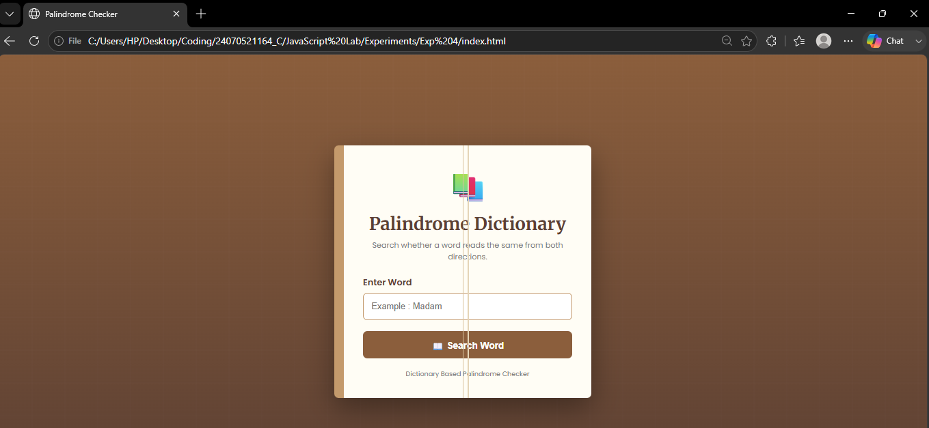

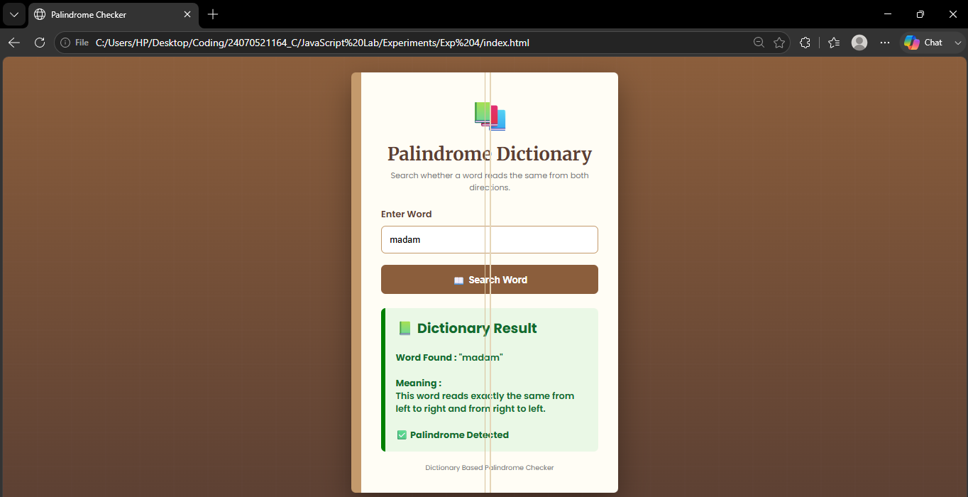
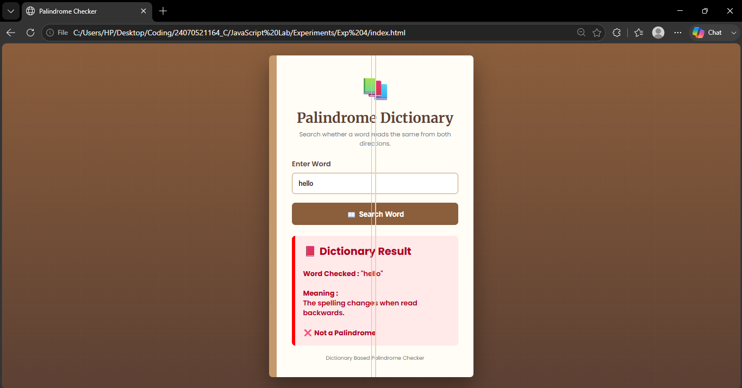

Result / Conclusion :-
The Palindrome Checker successfully identifies whether the entered text is a palindrome by comparing the original and reversed strings after preprocessing. The experiment demonstrates the use of JavaScript functions, closures, scope, and exception handling while providing an interactive and user-friendly interface.

CASE STUDY -04

Aim :
To develop a Password Strength Checker using HTML, CSS, and JavaScript that evaluates the strength of a user-entered password based on palindrome logic and demonstrates the use of JavaScript functions, scope, closures, form validation, and exception handling.

Software / Tools Required :

- Visual Studio Code (VS Code)
- Google Chrome / Any Web Browser
- HTML
- JavaScript

CODE :

Index.html
<!DOCTYPE html>
<html lang="en">
<head>

<meta charset="UTF-8">
<meta name="viewport" content="width=device-width, initial-scale=1.0">

<title>Password Strength Checker</title>

<link href="https://fonts.googleapis.com/css2?family=Poppins:wght@300;400;600&display=swap" rel="stylesheet">

<style>

*{
margin:0;
padding:0;
box-sizing:border-box;
font-family:Poppins,sans-serif;
}

body{

height:100vh;

display:flex;
justify-content:center;
align-items:center;

background:#050816;

overflow:hidden;

}

/* Animated Background */

body::before{

content:"";

position:absolute;

width:100%;
height:100%;

background:
linear-gradient(rgba(0,255,150,.08) 1px, transparent 1px),
linear-gradient(90deg, rgba(0,255,150,.08) 1px, transparent 1px);

background-size:45px 45px;

animation:gridMove 10s linear infinite;

}

@keyframes gridMove{

0%{transform:translateY(0);}
100%{transform:translateY(45px);}

}

.card{

position:relative;

width:430px;

padding:35px;

background:#0f172a;

border:2px solid #00ff99;

border-radius:18px;

box-shadow:
0 0 20px #00ff99,
0 0 60px rgba(0,255,150,.2);

text-align:center;

overflow:hidden;

z-index:1;

}

.scan{

position:absolute;

left:0;

top:0;

width:100%;

height:4px;

background:#00ff99;

box-shadow:0 0 15px #00ff99;

animation:scan 3s linear infinite;

}

@keyframes scan{

0%{top:0;}

50%{top:96%;}

100%{top:0;}

}

.icon{

font-size:60px;

margin-bottom:10px;

}

h1{

color:#00ff99;

margin-bottom:5px;

}

.subtitle{

color:#cbd5e1;

font-size:14px;

margin-bottom:25px;

}

input{

width:100%;

padding:15px;

background:#111827;

border:2px solid #00ff99;

outline:none;

color:white;

font-size:16px;

border-radius:10px;

transition:.3s;

}

input:focus{

box-shadow:0 0 20px #00ff99;

}

button{

margin-top:20px;

width:100%;

padding:15px;

background:#00ff99;

color:black;

font-size:17px;

font-weight:bold;

border:none;

border-radius:10px;

cursor:pointer;

transition:.3s;

}

button:hover{

background:white;

transform:scale(1.03);

box-shadow:0 0 25px #00ff99;

}

#result{

display:none;

margin-top:25px;

padding:18px;

border-radius:12px;

font-weight:bold;

font-size:18px;

}

.weak{

background:#ff3b30;

color:white;

border:2px solid white;

}

.strong{

background:#00c853;

color:white;

border:2px solid white;

}

.error{

background:#ff9800;

color:white;

}

footer{

margin-top:18px;

color:#94a3b8;

font-size:12px;

}

</style>

</head>

<body>

<div class="card">

<div class="scan"></div>

<div class="icon">🔒</div>

<h1>Password Strength Checker</h1>

<p class="subtitle">

Cyber Security Password Validator

</p>

<input

type="password"

id="password"

placeholder="Enter Secure Password">

<button onclick="checkPassword()">

Analyze Password

</button>

<div id="result"></div>

<footer>

JavaScript Practical Project

</footer>

</div>

<script src="script.js"></script>

</body>
</html><!DOCTYPE html>
<html lang="en">
<head>

<meta charset="UTF-8">
<meta name="viewport" content="width=device-width, initial-scale=1.0">

<title>Password Strength Checker</title>

<link href="https://fonts.googleapis.com/css2?family=Poppins:wght@300;400;600&display=swap" rel="stylesheet">

<style>

*{
margin:0;
padding:0;
box-sizing:border-box;
font-family:Poppins,sans-serif;
}

body{

height:100vh;

display:flex;
justify-content:center;
align-items:center;

background:#050816;

overflow:hidden;

}

/* Animated Background */

body::before{

content:"";

position:absolute;

width:100%;
height:100%;

background:
linear-gradient(rgba(0,255,150,.08) 1px, transparent 1px),
linear-gradient(90deg, rgba(0,255,150,.08) 1px, transparent 1px);

background-size:45px 45px;

animation:gridMove 10s linear infinite;

}

@keyframes gridMove{

0%{transform:translateY(0);}
100%{transform:translateY(45px);}

}

.card{

position:relative;

width:430px;

padding:35px;

background:#0f172a;

border:2px solid #00ff99;

border-radius:18px;

box-shadow:
0 0 20px #00ff99,
0 0 60px rgba(0,255,150,.2);

text-align:center;

overflow:hidden;

z-index:1;

}

.scan{

position:absolute;

left:0;

top:0;

width:100%;

height:4px;

background:#00ff99;

box-shadow:0 0 15px #00ff99;

animation:scan 3s linear infinite;

}

@keyframes scan{

0%{top:0;}

50%{top:96%;}

100%{top:0;}

}

.icon{

font-size:60px;

margin-bottom:10px;

}

h1{

color:#00ff99;

margin-bottom:5px;

}

.subtitle{

color:#cbd5e1;

font-size:14px;

margin-bottom:25px;

}

input{

width:100%;

padding:15px;

background:#111827;

border:2px solid #00ff99;

outline:none;

color:white;

font-size:16px;

border-radius:10px;

transition:.3s;

}

input:focus{

box-shadow:0 0 20px #00ff99;

}

button{

margin-top:20px;

width:100%;

padding:15px;

background:#00ff99;

color:black;

font-size:17px;

font-weight:bold;

border:none;

border-radius:10px;

cursor:pointer;

transition:.3s;

}

button:hover{

background:white;

transform:scale(1.03);

box-shadow:0 0 25px #00ff99;

}

#result{

display:none;

margin-top:25px;

padding:18px;

border-radius:12px;

font-weight:bold;

font-size:18px;

}

.weak{

background:#ff3b30;

color:white;

border:2px solid white;

}

.strong{

background:#00c853;

color:white;

border:2px solid white;

}

.error{

background:#ff9800;

color:white;

}

footer{

margin-top:18px;

color:#94a3b8;

font-size:12px;

}

</style>

</head>

<body>

</div>

<script src="script.js"></script>

</body>
</html>

Script.js

// =======================================
// Global Scope
// =======================================

let applicationName = "Password Strength Checker";

// =======================================
// Function Declaration
// Cleans the password
// =======================================

function cleanPassword(password) {
return password.toLowerCase();
}

// =======================================
// Function Expression
// Reverses the password
// =======================================

const reversePassword = function(password) {
return password.split("").reverse().join("");
};

// =======================================
// Arrow Function
// Checks if password is palindrome
// =======================================

const isPalindrome = (password) => {
password = cleanPassword(password);
return password === reversePassword(password);
};

// =======================================
// Closure Example
// Counts number of password checks
// =======================================

function passwordCounter() {

let count = 0; // Local Scope

return function () {

count++;

console.log("Passwords Checked :", count);

};

}

const checkCount = passwordCounter();

// =======================================
// Main Function
// =======================================

function checkPassword() {

try {

let password = document.getElementById("password").value;

if (password.trim() === "") {
throw "Password cannot be empty.";
}

// Count how many passwords have been checked
checkCount();

let result = document.getElementById("result");

result.style.display = "block";

if (isPalindrome(password)) {

result.className = "weak";

result.innerHTML = `
<h2>❌ SECURITY ALERT</h2>
<br>
<strong>Password Status:</strong> WEAK
<br><br>
<strong>Reason:</strong><br>
Your password is a palindrome.<br>
It is predictable and less secure.
`;
}

else {
result.className = "strong";
result.innerHTML = `
<h2>🛡 ACCESS GRANTED</h2>
<br>
<strong>Password Status:</strong> STRONG
<br><br>
<strong>Reason:</strong><br>
Your password is not a palindrome.<br>
It is comparatively harder to predict.
`;
}
}

catch (error) {
let result = document.getElementById("result");
result.style.display = "block";
result.className = "error";
result.innerHTML = `
<h2>⚠ ERROR</h2>
<br>
${error}
`;
}
}

Output :

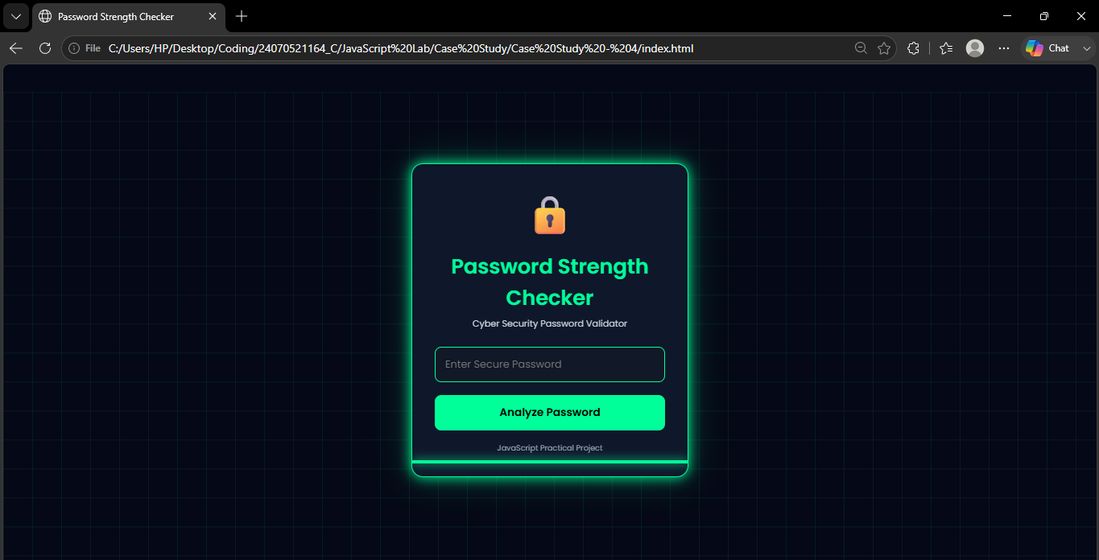

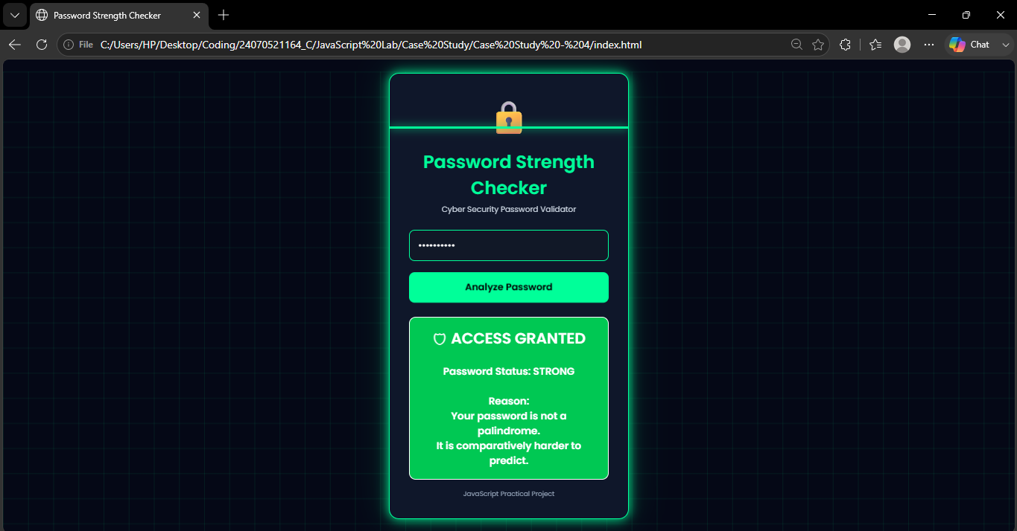

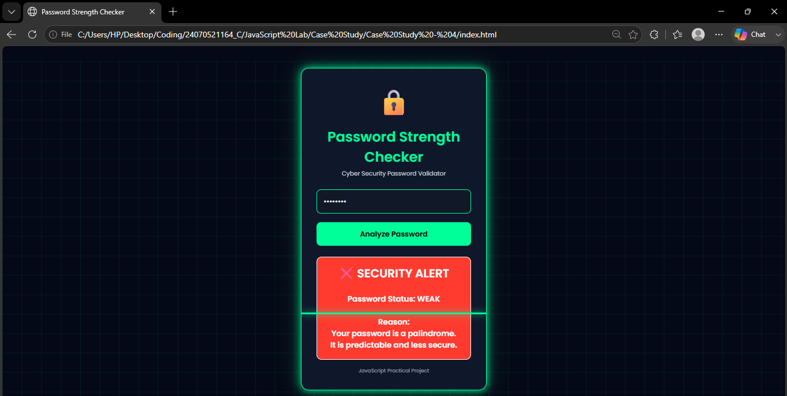

Result / Conclusion : The Password Strength Checker was successfully developed using HTML, CSS, and JavaScript. The application correctly identifies whether the entered password is a palindrome and classifies it as weak or strong while handling invalid input through exception handling. This case study demonstrates the practical implementation of JavaScript functions, closures, scope, and DOM manipulation in creating an interactive web application.

